Pizza sales KPI
Total Revenu
SELECT SUM([total_price]) Total_revenue

FROM [pizza_sales]
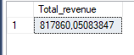

Average_order_value
SELECT SUM([total_price]) /

COUNT ( DISTINCT order_id) Average_order_value

FROM [pizza_sales]
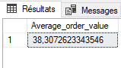

Total Pizza sold
SELECT SUM (quantity)
FROM pizza_sales
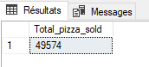

Total orders
SELECT COUNT (DISTINCT order_id) Total_orders
FROM pizza_sales
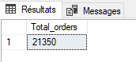

Average_pizza_per_order
SELECT CAST (CAST(SUM (quantity)AS DECIMAL(10,2) )/
CAST (COUNT(DISTINCT order_id) AS DECIMAL (10,2)) AS DECIMAL (10,2)) Average_pizza_per_order
FROM pizza_sales
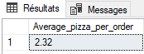

Daily Trend of total orders
SELECT DATENAME (DW, order_date) AS Order_day, COUNT(DISTINCT order_id) as Total_orders

FROM pizza_sales

GROUP BY DATENAME (DW, order_date)
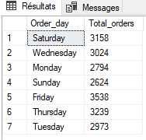

Monthly Trend of total orders
SELECT DATENAME (MM, order_date) AS Order_month, COUNT(DISTINCT order_id) as Total_orders

FROM pizza_sales

GROUP BY DATENAME (MM, order_date)

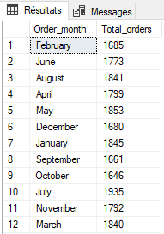

Percentage of sales per pizza category
SELECT pizza_category , SUM (total_price) as Total_sales, SUM (total_price) / (SELECT SUM(total_price) FROM pizza_sales) as Sales_percentage
FROM pizza_sales

GROUP BY pizza_category
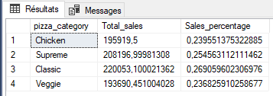

Percentage of sales per pizza size
SELECT pizza_size,
SUM (total_price) as Total_sales,
CAST(SUM (total_price) / (SELECT SUM(total_price) FROM pizza_sales) AS DECIMAL (10,3)) AS Sales_percentage

FROM pizza_sales
GROUP BY pizza_size
ORDER BY Total_sales

SELECT * FROM pizza_sales
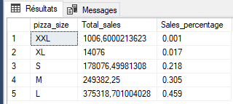

Top 5 Best sellers by Revenue, Total_quantity and Total_orders
Revenue
SELECT TOP 5 pizza_name,
CAST (SUM (total_price) AS DECIMAL(10,2)) AS Total_revenue

FROM pizza_sales
GROUP BY pizza_name
ORDER BY SUM (total_price) desc
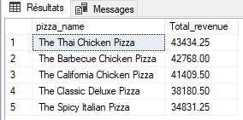

Quantity
SELECT TOP 5 pizza_name,
SUM(quantity) AS Total_quantity

FROM pizza_sales
GROUP BY pizza_name
ORDER BY Total_quantity DESC
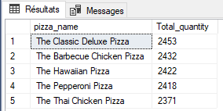

Orders
SELECT TOP 5 pizza_name,
COUNT (DISTINCT order_id) AS Total_orders

FROM pizza_sales
GROUP BY pizza_name
ORDER BY COUNT (DISTINCT order_id) DESC
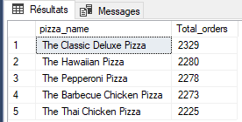

Top 5 Bottom sellers by Revenue, Total_quantity and Total_orders
Revenue
SELECT TOP 5 pizza_name,
CAST (SUM (total_price) AS DECIMAL(10,2)) AS Total_revenue

FROM pizza_sales
GROUP BY pizza_name
ORDER BY SUM (total_price) ASC
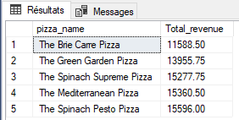

Quantity
SELECT TOP 5 pizza_name,
SUM(quantity) AS Total_quantity

FROM pizza_sales
GROUP BY pizza_name
ORDER BY Total_quantity ASC
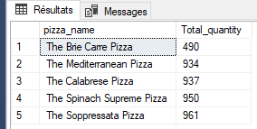

Orders
SELECT TOP 5 pizza_name,
COUNT (DISTINCT order_id) AS Total_orders

FROM pizza_sales
GROUP BY pizza_name
ORDER BY COUNT (DISTINCT order_id) ASC
